The Bushranger’s Daughter
By
Michelle Worthington

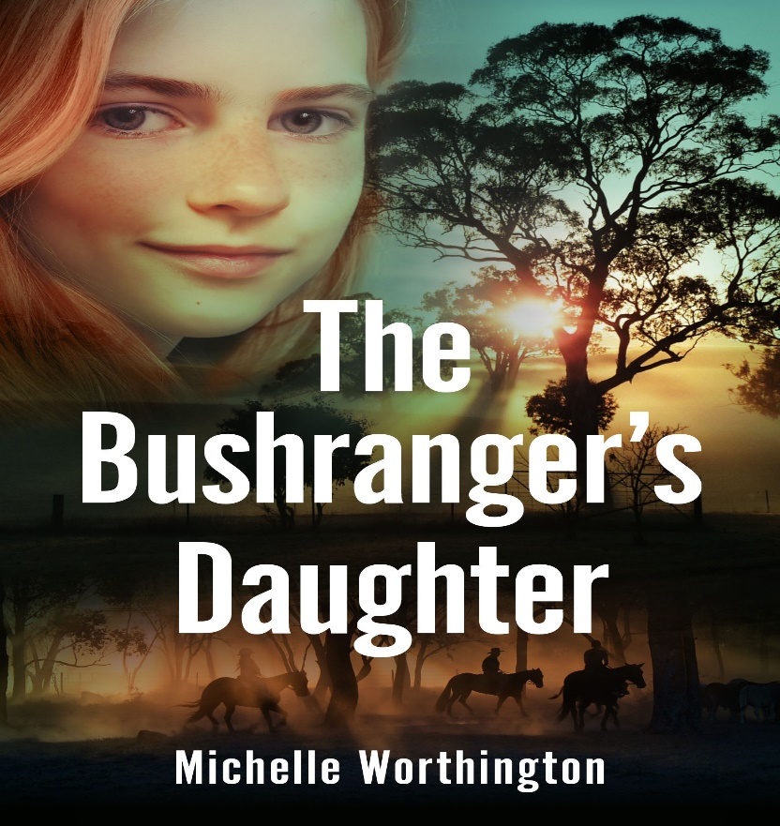

Teachers’ Notes

NOTE: These notes may be reproduced free of charge for educational purposes only.
CONTENTS
BOOK DESCRIPTION
ABOUT THE AUTHOR
AUTHOR INSPIRATION
CHARACTERS
- The Significance of Character
- Major Characters
- Character Arcs
THEMES
- Bushrangers
- Wealth, Class and Unemployment
- Women’s History and Rights
CURRICULUM TOPICS
- Language and Literacy
- SOSE

BOOK DESCRIPTION
Tagline: Bushrangers: heroes or villains? Sometimes good people do bad things to survive.
A young Scottish couple, eager to leave their overbearing families behind, were enticed by the opportunity and freedom a new country like Australia could offer. They were grossly unprepared for the life they would lead as a pioneer family in both New South Wales and Queensland. Told through the eyes of Constance, their only surviving daughter, the story draws from factual accounts of the author’s own family history and research into the living conditions, treatment of women and their prospects for the future in an ancient land.
As they travel from the slab hut at the drought ravaged Bream Creek to promise of prosperity at Wild Horse Plains, Connie learns more about the reasons behind why her parents wanted to leave England. The harsh reality of living in an untamed land threatens their lives constantly.
When they begin to rebuild their lives, it seems as if they have finally left the family legacy of death behind. There are marriages and prosperous times, but the harsh climate continues to threaten their happiness, with a flood that wipes out their flock.
This novel, although fictional, is the first in a series that provides a complete history of one of the major pioneering families in Western Queensland. Who were the people who decided that the conditions of settlement seemed favourable and were inspired with the idea to be a pioneer settler in a wild new land?

ABOUT THE AUTHOR
A full-time writer based in Brisbane, Michelle Worthington is an international award-winning author, scriptwriter and actor. She credits her three sons for giving her an endless source of inspiration, as well as her wrinkles.
Two-time winner of the International Book Award, Michelle has twice been short listed for a CBCA Picture Book of the Year Award and Australian Speech Pathology Award. Michelle was the recipient of the 2018 AusMumpreneur Gold Award for Business Excellence and the winner of the 2018 Redlands BaR award for Best Start Up Business. Her scripts have been finalists at the California Women's Film Festival, Kids First Film Festival, Gold Coast International Film Festival and 4th Dimension International Indie Film Festival. In 2021, she won the AFIN International Film Award for Best Screenplay.
Michelle is dedicated to encouraging a strong love of reading and writing in young children and enjoys working with charities that support the vision of empowering youth through education. As a mentor and editor, she helps aspiring authors find pathways to publication and enjoys working as part of a team in projects that are purposeful, innovative and inspirational.

AUTHOR INSPIRATION
This novel is an account of the author’s own family history. Her great great great grandfather Elias Harding Sr was one of the first free settlers in Australia and his son Elias Jnr was one of the earliest pioneers. In the early 1830 when Elias Snr and his wife arrived from England, Victoria was still part of the colony of New South Wales. Her research has found that he received a grant of 1000 acres from the Government and become the pioneer settler at Bream Creek near Geelong, and was in due course able to take up several thousand acres of leasehold land in the same area. Apart from running sheep, he was amongst those who pioneered the wheat industry in Australia. Part of his property is now the site of the Geelong race course.
In 1862, they settled at Wild Horse Plains at Mungallala Creek, not far from the present town of St George and in well-grassed land adjoining Bindebango Station in Queensland. They also acquired two other properties in 1863, further to the north and also on Mungallala Creek and further west near Cunnamulla. There is still a picnic ground near Ipswich named after her great great-grandfather. The established properties are still working stations but are no longer owned by the family. With all early pioneer settlers, many hardships had to be overcome, requiring courage and great fortitude. The rains bought floods, and the dry seasons led to drought. This is the story of how they came and made a new life for themselves in a new country with the hopes of a better life.

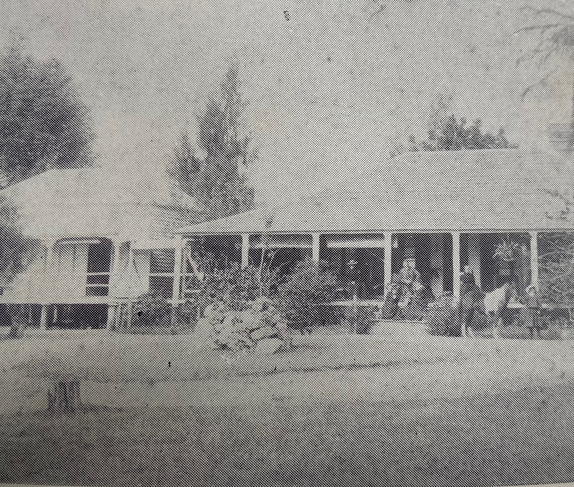
CHARACTERS
The Significance of Character
Historical fiction author Pamela Rushby says, ‘Characters are the heart of any narrative, the catalysts for action, and the central core around which all other narrative aspects must revolve and work.’
- Draw from real life. Sometimes, creative writing needs to take inspiration from the real human beings who already exist in our own lives. Using people familiar to you like family members or friends as a foundation to build your fictional character upon is a good way to ensure you’re writing a realistic person and not a caricature.
- Incorporate flaws. A great character is a flawed character. An invincible main character who can do it all is not as interesting to read about unless there is something else about them that can connect them with your audience. Even the greatest heroes have weaknesses that create conflict when exploited—that’s what makes them more interesting characters.
- Include mannerisms. Sometimes it’s the little things about a character’s personality traits or body language that makes them feel more grounded in real life. In fiction writing, a good combination of quirks can help create more memorable characters by including small things that make them charming, endearing, weird, or unique. However, overloading your character descriptions with these traits will have the opposite effect, and make them feel ungrounded and unrelatable.
- Give the character motivation. A character’s goals are integral to figuring out who they are and what drives them. In order for a bad guy to be a good character, they need a legitimate reason to be bad. What does this person want, and why do they want it this way? The best villains aren’t cartoonish caricatures; a good villain is a complex bad guy who readers simultaneously love and hate. Finding a way to present the internal conflict within a character will show the emotional struggle they face along with any physical obstacles or roadblocks. Writing realistic motivations will create believable character arcs for audiences to follow.
- Write realistic dialogue. The way your character speaks has a big impact on how a reader envisions them through your writing. The more organic their conversations are with other characters, the more lifelike they’ll feel. Dialogue should reflect your character’s background and be true to the period the story exists within. Find our tips for writing realistic dialogue here.
- Include relationships with supporting characters. When your main characters interact with secondary characters, it gives the reader the idea that these people have existed together long before you tuned in to their story. Having them interact with secondary and more minor characters will make them feel more like real people, like they still exist in the world even when we’re outside the central storyline.
- Develop your characters. Character development is an important aspect of any fiction writing, even if all that changes is their physical description or point of view. A character should learn and grow, or at least experience or learn something new during their story.

Major Characters:
Connie
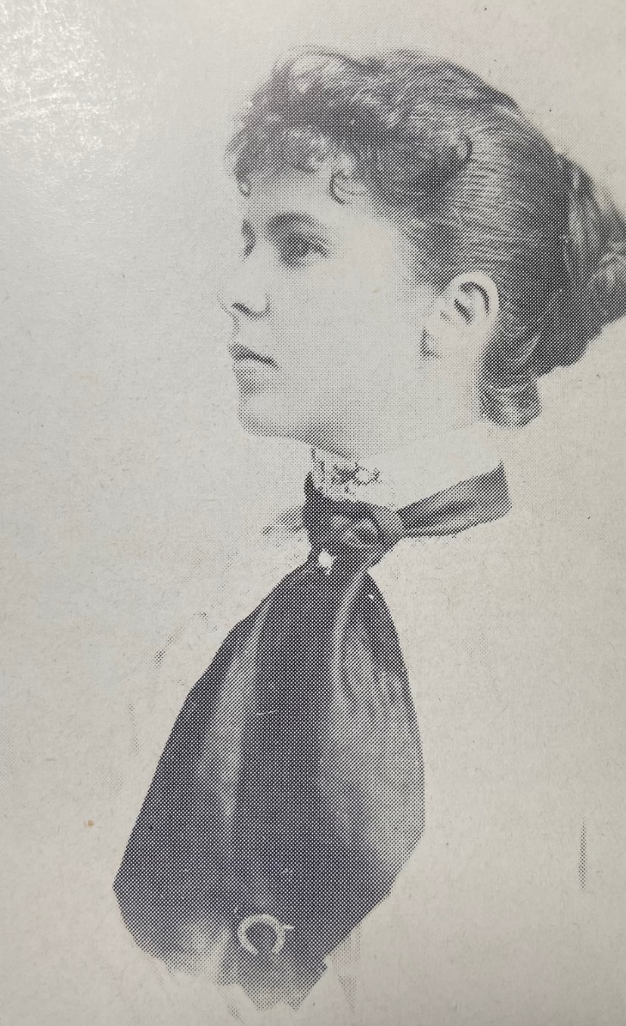
“Why should grownups be the only ones who get to understand the world? They hardly even see things for how they really are.” - page 16.
Constance Emily Harding was born at Bream Creek. They arrived at Wild Horse Plains in 1872She grew to be tall and slender, with an alert oval face, the only surviving daughter and the venturesome one of the family, eager for new experiences and full of enthusiasm for life.
Women at the time, particularly in far out areas of Queensland, were often dependent on each other in times of sickness and hardship, and the nearest neighbour might be many miles away.
Discussion Point:
Even though Connie lived a long time ago, are there things that you can still relate to about how she thinks?
If you were Connie, what would you have done at the end of the story?

Silas
‘Somewhere, deep inside, no matter how scared she was, she knew she would always follow Silas into the darkness.’ Page 71
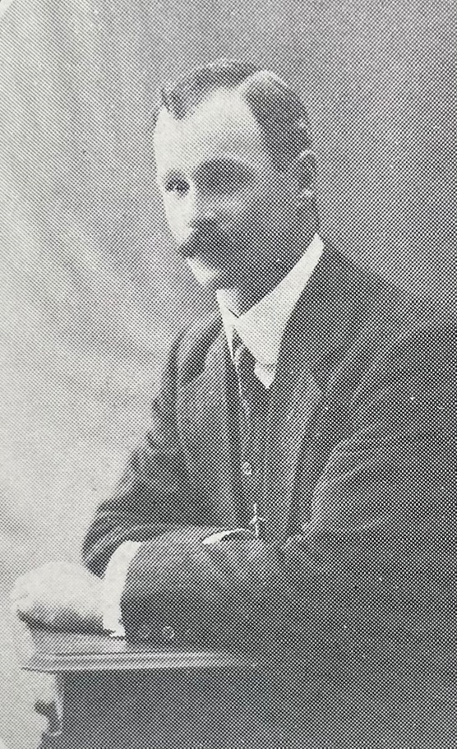

Silas Harding was a steadfast pioneer who married Johanna Sophia “Janey” Hiller Harding. He was fortunate in having a loving and loyal partner to share so many years of his life. As a child, we was never still. He had a winning smile and a loveable personality. As he grew older, he was intensely interested in animals. Pioneering was fraught with many dangers and great loneliness, and sickness took its toll, but the tradition of pioneering was to be an inspiration and an example to his family for many years to come.
Connie stared at the sun, unable to meet Jo’s big brown eyes that were framed with long dark lashes trimmed with diamond 116 The Bushranger’s Daughter drops of water. Jo’s chest and arms were strong, and her legs were long and slender. The colour of her skin was sun-kissed silk, and her hair was chocolate-brown, wavy and long. ‘Because you are beautiful. I was just wondering what that felt like.’ She waited for Jo to laugh, but she didn’t. – page 117

Discussion Point:
Which of the main characters did you find most appealing, and why?

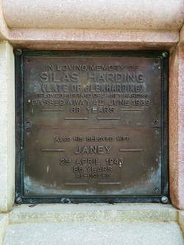
Character Arcs are the curve on which key events show how a character grows or develops in response to events and to interactions with other characters in the novel.
Activity: Choose a character and trace an arc on which key events indicate some aspect of their personality or change in their behaviour.
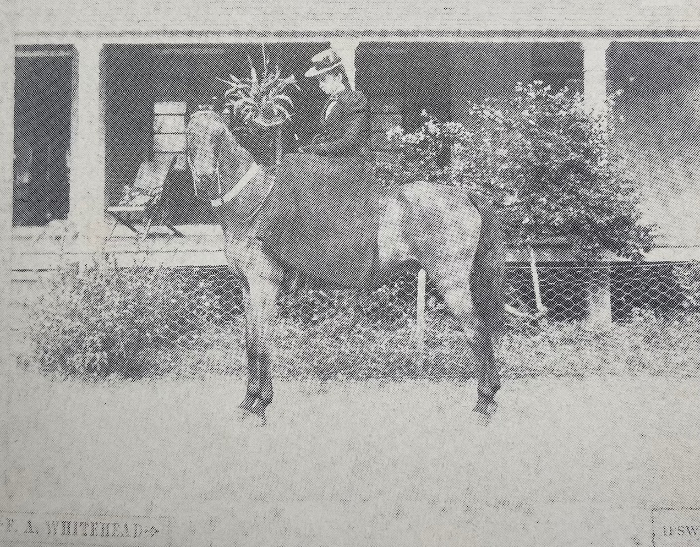

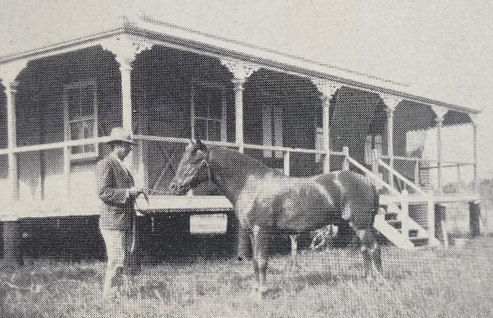

THEMES

Bushrangers

Bushrangers were originally escaped convicts in the early years of the British settlement of Australia who used the bush as a refuge to hide from the authorities. By the 1820s, the term had evolved to refer to those who took up "robbery under arms" as a way of life, using the bush as their base.
Bushranging thrived during the gold rush years of the 1850s and 1860s when the likes of Ben Hall, Bluecap, and Captain Thunderbolt roamed the country districts of New South Wales. These "Wild Colonial Boys", mostly Australian-born sons of convicts, were roughly analogous to British "highwaymen" and outlaws of the American Old West, and their crimes typically included robbing small-town banks and coach services. In certain cases, such as that of Dan Morgan, the Clarke brothers, and Australia's best-known bushranger, Ned Kelly, numerous police officers were murdered.
The concept of bushranging exerted a powerful influence in Australia, lasting for over a century and predominating in the eastern colonies. Its origins in a convict system bred a unique kind of desperado, most frequently with an Irish political background. Native-born bushrangers also expressed nascent Australian nationalist views and are recognised as "the first distinctively Australian characters to gain general recognition." As such, a number of bushrangers became folk heroes and symbols of rebellion against the authorities, admired for their bravery, rough chivalry and colourful personalities. However, in stark contrast to romantic portrayals in the arts and popular culture, bushrangers tended to lead lives that were "nasty, brutish and short", with some earning notoriety for their cruelty and bloodthirst. Australian attitudes toward bushrangers remain complex and ambivalent.

• Discussion Points:
‘What about the cattle? Don’t they already have a brand on them? Don’t they belong to someone else?’ asked Connie. ‘Yes,’ said Silas, putting a heavy calloused hand on her shoulder. ‘Yes, they do.’ He nodded before walking Connie to the shed that held their own iron brand hanging on the wall. ‘But desperate times call for desperate measures. Do you understand?’ – page 147
What kind of crimes did bushrangers commit?
What kind of punishment could a bushranger expect if they were caught?
What were some different reasons people turned to bushranging?
Why did the number of bushrangers decline?
Were bushrangers heroes or villains?

Resource: Were bushrangers villains or heroes? | Sydney Living Museums
Wealth, Class and Unemployment
Queensland, under the administration of New South Wales, had been opened to ‘free settlement’ in 1842 and it became an independent colony, with a government of its own, in 1859. The capital of Brisbane was incorporated in 1859. Ipswich, previously called Limestone, was nearly chosen as the capital as it was a prosperous town with a very solid business centre. Until the railway was established, transport depended almost solely on horses. Shearing was done by hand and by careful breeding, the flocks of sheep were improved. Child mortality was high, as the wives, isolated on their properties, had their babies without the help of a doctor.
• Discussion Point:
‘What about my future? I don’t want to leave. I don’t want to learn how to be a good wife.’ Connie finally understood what her brother was talking about down by the creek. They were not free to choose their own destiny.’ – page 164
How would Connie’s future education at boarding school change her prospects, if at all?
• Discussion Point:
‘It was also the start of the sheepshearing season, and men had travelled from shed to shed southwards, 106 The Bushranger’s Daughter looking for work. Silas rode down to hire men or arranged to have them sent. Bush men moved readily from one job to another, spending their money and then moved on.’ – page 107
Why were so many people coming to Brisbane and the Queensland outback during that time?
• Discussion Point:
‘The seasons were much wetter than at Bream Creek, and there were often few rations, owing to flooded creeks and boggy roads on which no one could travel across. Supplies were sometimes delayed months on the road, and Da couldn’t spare any men to go and collect it.’ – page 114.
When supplies are not available to be accessed or purchased, what was the alternative for pioneering families?

Women’s History and Rights

Women looked after their children when they were sick, clothed, fed and taught them. They made their own bread, candles and soap and their families relied on them for comfort, love and encouragement.

• Discussion Point:
‘Connie wondered how many calm women boiled like her mother under the surface, trying not to let it spill over.’ – page 102
How is a mother’s role different or similar from then to now?
• Discussion Point:
‘As Connie helped Ma with the day-to-day running of a busy household, she found more and more ways to make her own choices and to be in charge, just like Silas had told her to.’ – page 78
What were options for employment for women in the late 1800s and early 1900s?
• Discussion Point:
‘Connie’s face felt numb. ‘Do you really think that’s all I’m good for? Marry and make babies?’ Tears welled in her eyes, and she could feel her heart clawing at the inside of her chest. The tiger was waking.’ – page 111
How does the expectation that a woman should marry fit in with societies expectations of women at the time?

CURRICULUM TOPICS

A student:
• composes, edits and presents well-structured and coherent texts (EN3-2A)
• uses an integrated range of skills, strategies and knowledge to read, view and comprehend a wide range of texts in different media and technologies (EN3-3A)
• uses knowledge of sentence structure, grammar, punctuation and vocabulary […] to compose clear and cohesive texts

Language and Literacy
• This novel is a work of Historical Fiction or Faction — a genre which relies on the author weaving together fact and fiction seamlessly. This novel is based on the real life experiences of people during pioneer times, meshed with fictional aspects of the story of Connie and her family.
Discussion Point: How much did you recognise from the history you have read?
What was similar and what was different to actual events or people?
Discussion Point: Talk about the writing of historical fiction and the importance of research.
Activity: Create a timeline of some of the incidents referred to in the book and some of the key milestones or turning points in the action.
• Narrative Perspective —Connie’s story is written in third person.
Discussion Point: How might the story have changed if it had been written in first person? Re-write a passage to see how it would change.
• The Cover of a book is an ideogram for the contents and a marketing tool as well.
Activity: This cover is a realistic portrait of Connie. Create a new cover using a different
artistic style (e.g. naive art, impressionistic art, collage). Write a blurb for the back cover
of the book as well.

SOSE
• Whose history? —History can be recounted from many different perspectives and in
many different voices. Imagine if the story had been told from John or Minnie’s perspective? How different would it be a contrasting experience of the times?
Try to find any first-person accounts and diaries of this era as an introduction to this topic.
Activity: Choose an incident referred to in the novel and re-write it in Minnie’s
voice.
• History of Queensland — There is much to discuss in this novel about the history
and the topography of Brisbane.
Activity: Research any topic suggested by the novel e.g. Town planning, Charleville, Charlotte Plains, Ipswich, Floods.
Activity: Wild Horse Plains was not the only sheep station in Queensland. Research the
history of others such as Charlotte Plains.
• Living Conditions — Connie’s family are dependent on the climate for their livelihood and their living conditions vary depending on the weather.
Activity: What other aspects of the environment did you discover from reading this book?
• Values — This novel demonstrates certain aspects of ‘character’ and values. Sometimes good people do bad things to survive.
Activity: List some of the values demonstrated in any of the scenes or events in this
book with a corresponding quote to illustrate it.
• Individual/Community — Connie’s primary duties are to her family but she also feels like there could be more for her to do as well.
Discussion Point: What other examples of a woman’s responsibility to the individual or family, coming into conflict?
www.bigskypublishing.com.au

